RESUME
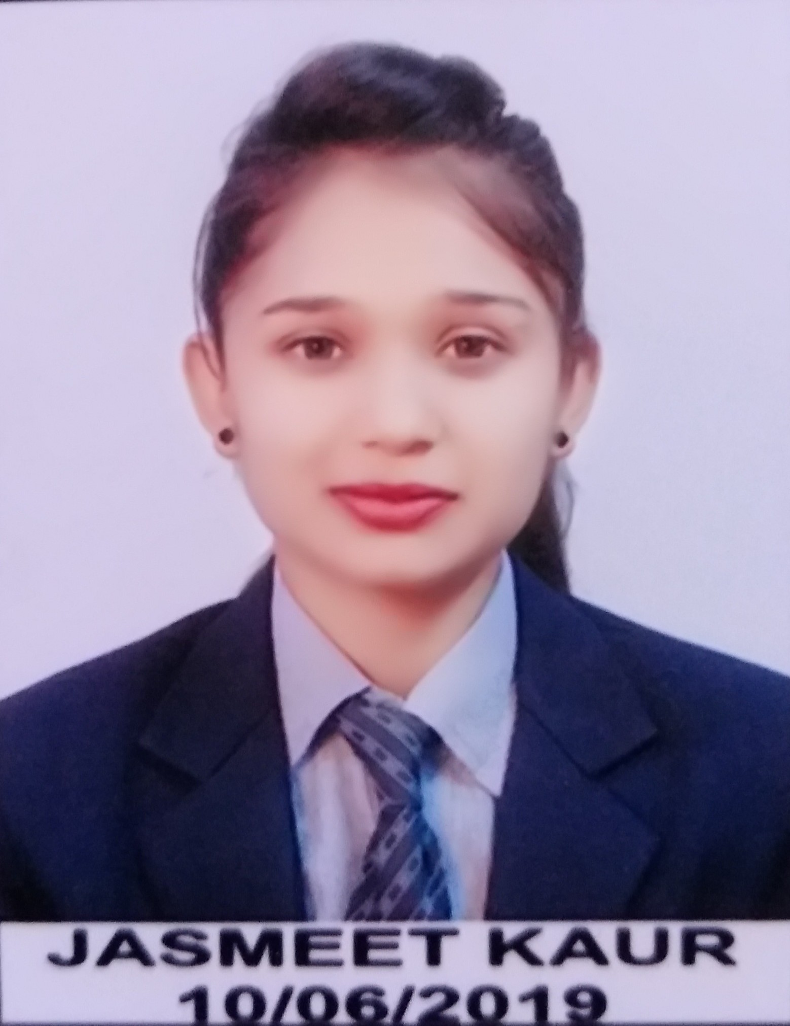

Jasmeet Kaur

Mobile: 9644067028

Email: jasmeetkaursekhon12@gmail.com
Address : H.No. 141, Sheetal City, Mandideep

CAREER OBJECTIVE

Seeking a Full Stack Web Developer position with a progressive employer where I can contribute to the development of new technologies and work with the bright and committed people.

ACADEMICS

Degree | Board/university | School/College | Passing | Percentage
 |  |  | Year | /CGPA
 |  | NRI Group of Institutions |  | 7.48(6th Sem.)
B.E.(CS) | RGPV |  | 2020 | 7.48(6th Sem.)
12th | MP | Graphite Hr. Sec. School | 2015 | 84.4%
10th | MP | C.L. Arya Public School | 2013 | 84.5%

WORKSHOPS

- Attended one-week workshop on Internet of Things conducted by Webgurukul at Sagar Institute of Science and Technology, Bhopal under RGPV in 2k19.

- Attended a one day workshop on “Assemble & Disassemble” at Oriental Institute of

Science and Technology, Bhopal.

PROJECTS

- Web Notes App: It is a web application that is designed using Django, a web framework of python and it contains notes of various subjects, syllabus and schemes that can be

- Completed one month training on PHP with NodeJs in the month of June 2019 from TCS Ion.

downloaded.

• Digital Locker App: It is a web application in which we can store our documents securely and it is designed by using Django, a framework of python.
SUMMER TRAINING

TECHNICAL SKILLS

- Programming languages like C, C++, Java and Python.
- Data structure (which is my subject of interest).
- PHP and Django (Web framework of Python) for backend web development.
- HTML, CSS, JavaScript for frontend web development.

ACHIEVEMENTS

- Got first prizes in classical dance competition held by Nagar Palika Mandideep.
- Got first prize in basketball match in the school.

STRENGTHS

- Leadership
- Quick Learner
- Flexible and Adaptable
- Honest
- Ethical

WEAKNESS

- I like taking risks.
- I am very people friendly.

PERSONAL INFORMATION

Name : Jasmeet Kaur
Father’s Name : Sukhwinder Singh
Date of Birth : April 12, 1997
Language Known : Hindi, English, Punjabi
Hobbies : Fashion Designing, Dancing, Cooking, Travelling

Place : Bhopal Jasmeet Kaur

